**Audit Exception Program Architecture and Technical Documentation.**

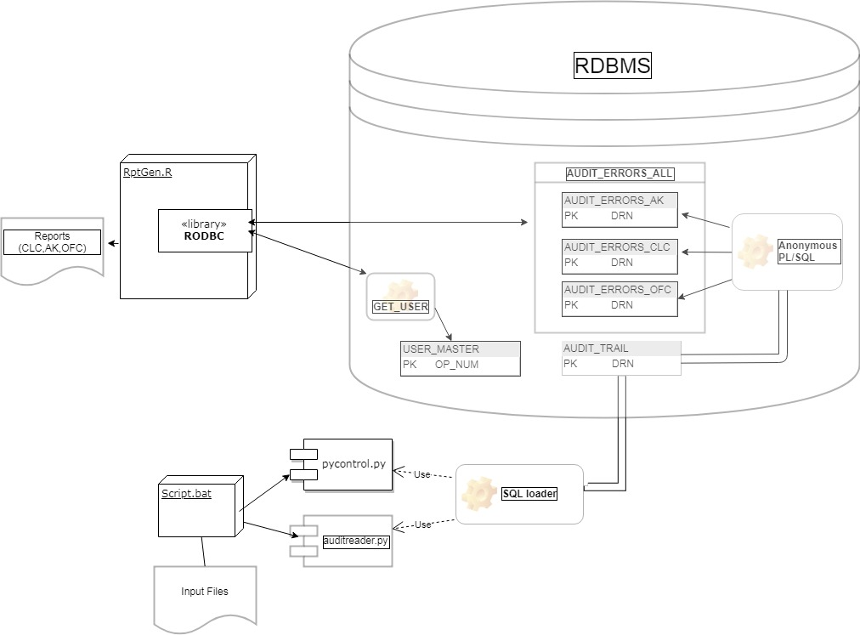

**Software Requirements**

|  |  |  |  |
| --- | --- | --- | --- |
| Name | Version | Comments | Source |
| Oracle Xe | 11.2.0.2.0 | RDBMS & PL/SQL engine | \\maple.fg.rbc.com\data\Toronto\APP\UYE0\myHandInstalls\Catalog.html |
| Oracle Client | 12.1.0.2.0 | SQL Loader component |
| Anaconda | Python 3.6.2 |  |
| R | R version 3.5.1 |  |

**Files and their respective usage**

|  |  |  |
| --- | --- | --- |
| Filename | Comments | Location |
| Script.bat | Main entry program to the program.<Should be double clicked to start the program> | C:\Repo\pto_audit\src |
| Pycontrol.py | Generates the control file for SQL Loader | C:\Repo\pto_audit\src |
| Auditreader.py | Polls the input directory and consumes all files. It extract the necessary data from the audit exception flat file and hands off to SQL loader for RDBMS load | C:\Repo\pto_audit\src |
| RptGen.r | Connects to the RDBMS to extract the processed data to user requested CSV. The processed files are written to the Output Folder. | C:\Repo\pto_audit\src |
|  |  |  |

**RDBMS Tables and View**

|  |  |  |
| --- | --- | --- |
| Name | Comments | Component Dependency |
| AUDIT_TRAIL | This table contains the cleaned data from the flat files parsed through the SQL Loader | SQL loader |
| AUDIT_ERRORS_AK | This table contains all AK related errors mined in the process. | Anonymous PL/SQL procedure executed by PL/SQL engine. |
| AUDIT_ERRORS_CLC | This table contains all CLC related errors mined in the process. |
| AUDIT_ERRORS_OFC | This table contains all OFC related errors mined in the process. |
| USER_MASTER | This table contains the mapping data for users. | RptGen.r |
| AUDIT_ERRORS_ALL | It’s a view created on AK, OFC & CLC tables. |

**HOW TO RUN APPLICATION**

Navigate to the home folder of the program as shown below. : C:\Repo\pto_audit.

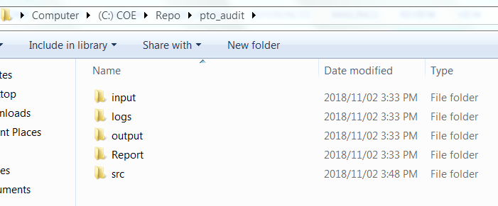

Place the APP exception report files into the input folder(C:\Repo\pto_audit\input) shown in the image above.

Navigate to the SRC folder (C:\Repo\pto_audit\src)

Double click on the file name Script.bat as shown below.

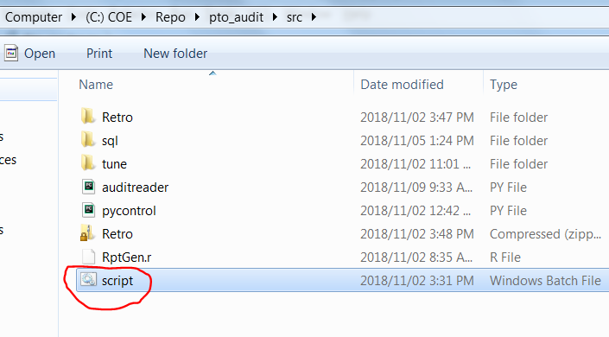

The interface is color coded indicating the state of the program.

Red means the program is not started as shown below.

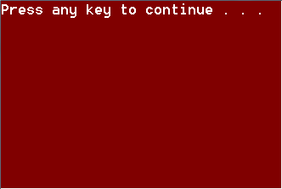

Yellow as shown below indicates the program is running

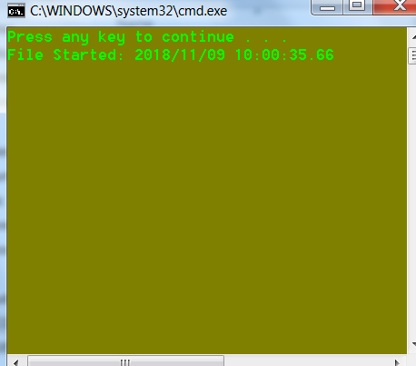

Green indicates the program has finished running as shown below.

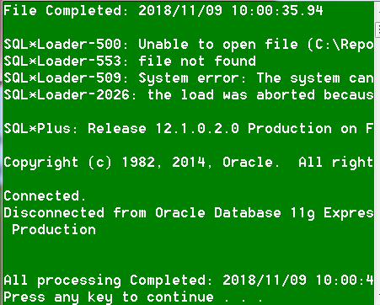

Navigate to the report folder and view the reports

